2023-2024 APPLICATION FOR ENROLLMENT
Application Process:
- Submit a completed application with $100.00 (per family/year) application fee.
- Include Transcript/List of Curricula used in 2022-23
- Schedule a Family Meeting for parents and student(s) with Andrew Natanael (281)309-1316 or logicalfaith@gmail.com
- The Board will notify family of decision to accept/decline admission based on the application & interview.
General Information:
Family Last Name:
Home Address
City/State/Zip Home Phone:
Family Email address
Father’s Name ________________
Address: Cell Phone
Mother’s Name ________ _________
Address: Cell Phone
Student (1) Name: D.O.B / /
Grade Entering ______________________ Education Last Year: ________
Please Attach transcript / curricula list
Desired status: Full-time student A la carte student (please specify classes on Enrollment Form)
Student (2) Name: D.O.B / /
Grade Entering: Education Last Year:
Please attach transcript / curricula list
Desired status: Full-time student A la carte student (please specify classes on Enrollment Form)
Names of other children Grade School Attending

Student educational background. Print out one for each student applying.
Name__ Schools attended
Grade completed Curricula used:
Attach Transcript/Curricula List
Comment on the strengths and weaknesses of the student’s previous education program(s):
_________________________________________________________________________________________________
______________
Briefly assess the student's learning experience: ______________
______________
__________________________________________________________________________________________________
Learning style ______________
Reading level ______________
Special gifts/challenges ______________
Student's personal information:
Child's responsibilities at home: ____________
__________________ _____
Other activities he/she participates in (e.g. athletics, recreation) __________________
_________________________
Interests/hobbies/pastimes/etc________________________________________________________________________
___________________
Please include any other information you think would be necessary or helpful to your child’s care while in class (allergies, learning disabilities, behavior problems, etc.). SEEDS in a POD is not equipped to educate students with serious emotional, physical, or learning disabilities. (Please use a separate sheet of paper if necessary.)
____________________________________________________________________________________________
______________

Learning Disabilities
SEEDS in a Pod is not equipped or staffed to accommodate students with learning disabilities or those who are having trouble with emotional or behavioral problems. For your child’s best interest, please be candid when you answer the following questions. Please answer this section for each child who is applying for admission to SEEDS in a Pod. A “yes” answer does not mean that the student will be immediately disqualified for admission to SEEDS in a Pod. Further elaboration on your answers may be requested during the Board interview. Please use a separate sheet of paper for additional children.

Student’s Name:
- Does your child have any learning disorders? | Yes No
- Has the student ever been examined or treated by a counselor/doctor/psychiatrist for hyperactivity or attention deficit disorder? | Yes No
- Has the student ever seen a counselor, doctor, psychiatrist for any type of social, behavioral or mental problems? | Yes No
- Has the student ever been referred for testing or placed in a special program? | Yes No
- Has the student ever been suspended by or expelled from a school? | Yes No
- Do you suspect or have you been told that your child may have dyslexia? | Yes No

Parent or Guardian Date

Parent or Guardian Date

Student’s Name:
- Does your child have any learning disorders? | Yes No
- Has the student ever been examined or treated by a counselor/doctor/psychiatrist for hyperactivity or attention deficit disorder? | Yes No
- Has the student ever seen a counselor, doctor, psychiatrist for any type of social, behavioral or mental problems? | Yes No
- Has the student ever been referred for testing or placed in a special program? | Yes No
- Has the student ever been suspended by or expelled from a school? | Yes No
- Do you suspect or have you been told that your child may have dyslexia? | Yes No

______
Parent or Guardian Date

________
Parent or Guardian Date
Family Information:
REFERENCES:
- Personal Reference (Not family): Name ________________________________________________________
Email_________________________________________________________Cell ________________________

- Past or Present SEEDS in a Pod Family: Name_______________________________________________

Email ________________________________________________________ Cell_________________________

- Pastor: Name_________________________________________________Cell__________________________
Email: _______________________________________________________ Cell__________________________
Church Currently Attending:
Church Address:
Please give a brief summary of your personal testimony.
Father: ______________
__________________________________________________________________________________________________
__________________________________________________________________________________________________
Mother: _______________
__________________________________________________________________________________________________
_________________________________________________________________________________________________

Please check and initial each of the following questions (1 – 3) located in the Family Handbook
- Do you agree to have your children taught according to SEEDS in a Pod’s Statement of Faith, Vision and Mission Statements?
Mother: Yes Initials ______ No Initials: _______ Father: Yes Initials ______ No Initials: _______
- Have you read and agree to all portions of the Family Handbook?
Mother: Yes Initials ______ No Initials: ______ Father: Yes Initials ______ No Initials: _______

- Do you support the following aspects of the curriculum and school policies? Please initial.
Discipline Policy: Mother: Yes No Father: Yes No
Dress Code: Mother: Yes No Father: Yes No
Student Rules of Conduct: Mother: Yes No Father: Yes No
Classical Emphasis: Mother: Yes No Father: Yes No
If you answered “No” to any of the above, please explain (use a separate sheet of paper if necessary).
______________________________________________________________________________________________
- Is either parent, step-parent, or guardian opposed to a Christian education? Yes No
If yes, please explain__________________________________________________________________________
- Does your child want to attend SEEDS in a Pod? If No, please explain Yes No
___________________________________________________________________________________________
- What expectations do you have from SEEDS in a Pod with respect to the discipline of your child/children?
__________________________________________________________________________________________
__________________________________________________________________________________________
- Are you willing to resolve any conflicts that may arise in accordance to the Communication Policy
in the Family Handbook? Yes No If “No”, please explain.
___________________________________________________________________________________________
___________________________________________________________________________________________

Signatures
We (I) hereby certify that all the foregoing information is accurate and true as of the date below. We (I) have signed the attached Statement of Faith representing that we (I) believe in and agree to the applicant(s) being educated based on the Statement of Faith. We (I) have carefully considered participation of our child(ren) in the SEEDS in a Pod. As parents (legal guardians), we (I) certify that we (I) support the philosophy of SEEDS in a Pod, and we (I) agree to require the applicant as well as ourselves to abide by all programs, and academic/disciplinary rules and regulations outlined by SEEDS in a Pod in the Family Handbook and other written materials. We understand that admission to SEEDS in a Pod is solely at the discretion of the Board members who operate the Study Center and that such admission may be terminated at any time.

Parent or Guardian Date

Parent or Guardian Date
STATEMENT OF FAITH

The following Christian beliefs shall be taught and shall be reflected in the policies and practices of SEEDS in a Pod at all grade levels.

1. We believe that the Bible, consisting of the sixty-six books of the Old and New Testaments, is the Word of God, inspired by the Holy Spirit, inerrant in the original writings, infallible, and the final authority in matters of faith and life. We believe that the Bible derives its authority from God its author, and not from the opinions of men.
2. We believe that there is one living and true God, eternally existent in three persons: Father, Son, and Holy Spirit. We believe the God we serve is the creator and sustainer of all things, and the source of all truth. He is all powerful, all knowing, holy, righteous, just, good, loving, and full of mercy.
3. We believe that God upholds, disposes, and governs all creatures, actions and things, and that God, in His ordinary providence, makes use of means, yet is free to work without, above, or against them at His pleasure.
4. We believe that because of Adam’s sin all mankind is in rebellion against God. For the salvation of such lost and sinful people, regeneration by the Holy Spirit is absolutely necessary.
5. We believe in the true deity and full humanity of our Lord Jesus Christ. We believe in His virgin birth, in his sinless life, in His miracles, in His vicarious and atoning death through His shed blood on the cross, in His bodily resurrection from the dead, in His ascension to the right hand of the Father, and in His personal return in power and glory.
6. We believe that salvation is by grace through faith in the Lord Jesus Christ alone, and that good works, done in obedience to God’s commandments, are the necessary fruits and evidences of a true and lively faith.
7. We believe in the present ministry of the Holy Spirit, by whose indwelling the Christian is enabled to live a godly life.
8. We believe in the resurrection of both the saved and the lost: those who are saved to the resurrection of life and those who are lost to the resurrection of damnation.

We (I) acknowledge and agree that all classes offered by SEEDS in a Pod will be taught in a manner consistent with SEEDS in a Pod’s Statement of Faith and Educational Philosophy found in the SEEDS Family Handbook.

We (I) agree with the SEEDS in a Pod’s Statement of Faith. (To be signed by at least one parent, preferably both.)

Father’s Signature ________________________________________________________Date____________________

Mother’s Signature _______________________________________________________Date ____________________

Are there any points in SEEDS in a Pod's Statement of Faith that are inconsistent with your convictions?

Yes No (If yes, please explain on back)

We (I) acknowledge and agree that all classes offered by SEEDS in a Pod will be taught in a manner consistent with SEEDS in a Pod's Statement of Faith. (Must be signed by both parents.)

Father’s Signature Mother’s Signature

STUDENT RULES OF CONDUCT

This is the basic code of conduct that SEEDS in a Pod requires all students to obey. Students observed disobeying by Tutors or the Parent of the Day will be sent immediately to the administrator.

- Students are expected to observe Christian standards of behavior and conversation. For example, students must speak honestly, respect their peers and submit to authority.
- Prompt and cheerful obedience is expected. Talking back or arguing with tutors, administrator or the Parent of the Day is not permitted.
- Students must comply with the dress code in all respects.
- Chewing gum, snacks etc. are only permitted when and where designated.
- Electronic media, (phones, iPods, ipads, etc.), musical devices or games are not permitted while at SEEDS unless approved by the Administrator or Tutor for classroom use. Any texting necessary for communication with parents must be discussed with the Administrator in advance
- Students are expected to be aware of and avoid the off-limit areas of the church building. Students should not play on or around cars in the parking lot.
- Running is not allowed in the church building.
- Students are expected to treat all class materials and facilities with respect and care.
- Students are expected to treat one another with kindness and respect. Teasing, criticizing, name-calling and other forms of verbal or physical abuse are not permitted.
- Students are expected to treat prayer and class discussion with proper reverence. Jokes, songs, or behaviors that attempt to trivialize or disrespect God are not permitted.
- Public displays of affection in the context of boy/girl relationships are not appropriate at SEEDS in a Pod. Likewise, jokes and teasing on this subject are not permitted.
- Any missed work due to absences should be completed in a timely manner as set forth in the Home Assignment Policy.
- Students may not speak out of turn during class time and must raise their hand and be recognized by the tutor prior to speaking.
- Disruptive class behaviors are prohibited.
- It is expected that students will work diligently, participate in class discussions and concentrate on their work while in class.
- Students accept responsibility to complete all homework assignments in a timely manner.
- Students recognize that they are held accountable for their conduct, both in action and attitude, by their parents, tutors and those in authority at SEEDS in a Pod.

Date:____________________________
Parent’s signature indicates parent reviewed with student.

Date:____________________________
Student's signature

Financial and Parent of the Day Agreement
Full-Time Students
SEEDS in a Pod is a donation based hybrid homeschool pod. Parents will be notified of the entire 2023-2024 projected budget (spending) ahead of time. For 2023-2024 school year, the entire budget will be allocated to the tutors. In the event that the donation does not meet our budget, Andrew Natanael and Nike Monica have committed to be responsible for the difference. This commitment is taken on a yearly basis; therefore, we urge that parents give generously and joyfully according to the Holy Spirit’s calling to ensure the continuation of this ministry. Donation can be made via Venmo to Rebecca Hummer or checks made payable to Andrew Natanael or Nike Monica.
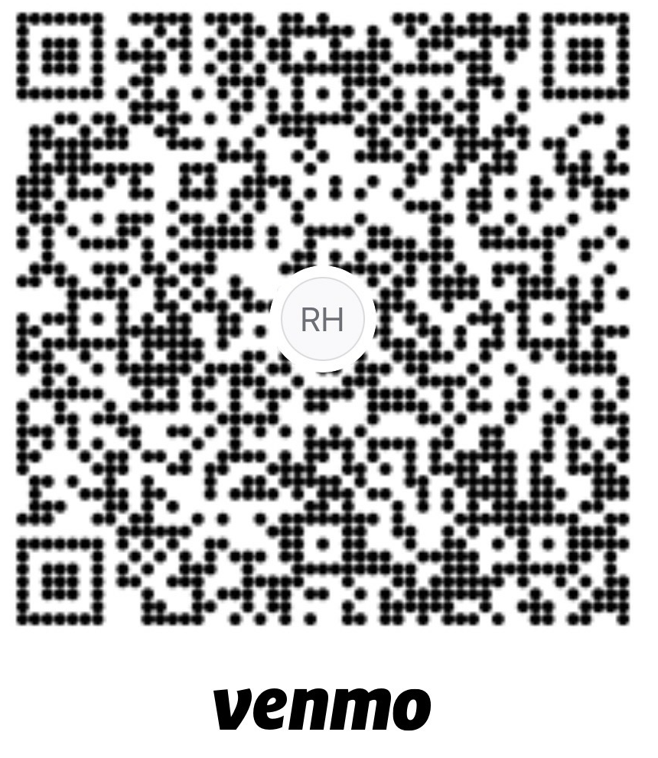
The checks must be received by July 15 or the student/s will be moved to the wait list and may be replaced. A fee of $30.00 will be charged for all returned checks.

I/we agree to honor the calling of the Holy Spirit to give joyfully.

Parent or Guardian Date

Parent or Guardian Date
Note: A non-refundable, one-time application fee of $100.00 per family/year is due with this application. This fee does not apply toward payment of tuition or books. If the applicant is accepted into SEEDS in a Pod, the application fee will be processed; otherwise, it will be returned.

Please make checks payable to Andrew Natanael.

PLEASE MAIL COMPLETED APPLICATION AND APPLICATION FEE TO:

Andrew Natanael
104 Suncrest CT
Canonsburg, PA 15317
logicalfaith@gmail.com

